Ideation Phase
Brainstorm & Idea Prioritization Template

Date | 31 January 2026
Team ID | LTVIP2026TMIDS78015
Project Name | Importing & Securing Data in Servicenow
Maximum Marks | 4 Marks

Brainstorm & Idea Prioritization (Project-Specific)
Brainstorming Overview
Brainstorming for the project “Importing & Securing Data in ServiceNow” was conducted to identify effective ways to manage data import processes while ensuring data confidentiality, integrity, and access control within the ServiceNow platform.
The goal was to explore multiple approaches for secure data handling, automation, and role-based access, keeping real-time enterprise requirements in mind.
During this phase, all possible ideas related to data import, validation, security, and monitoring were encouraged without restrictions. This helped in identifying scalable and secure solutions suitable for organizational use.
Step-1: Team Gathering, Collaboration and Select the Problem Statement
The team gathered to discuss real-world challenges related to data handling in enterprise platforms. After analyzing multiple problem statements, the team finalized “Importing & Securing Data in ServiceNow” as it addresses data security, automation, and access control issues commonly faced by organizations.
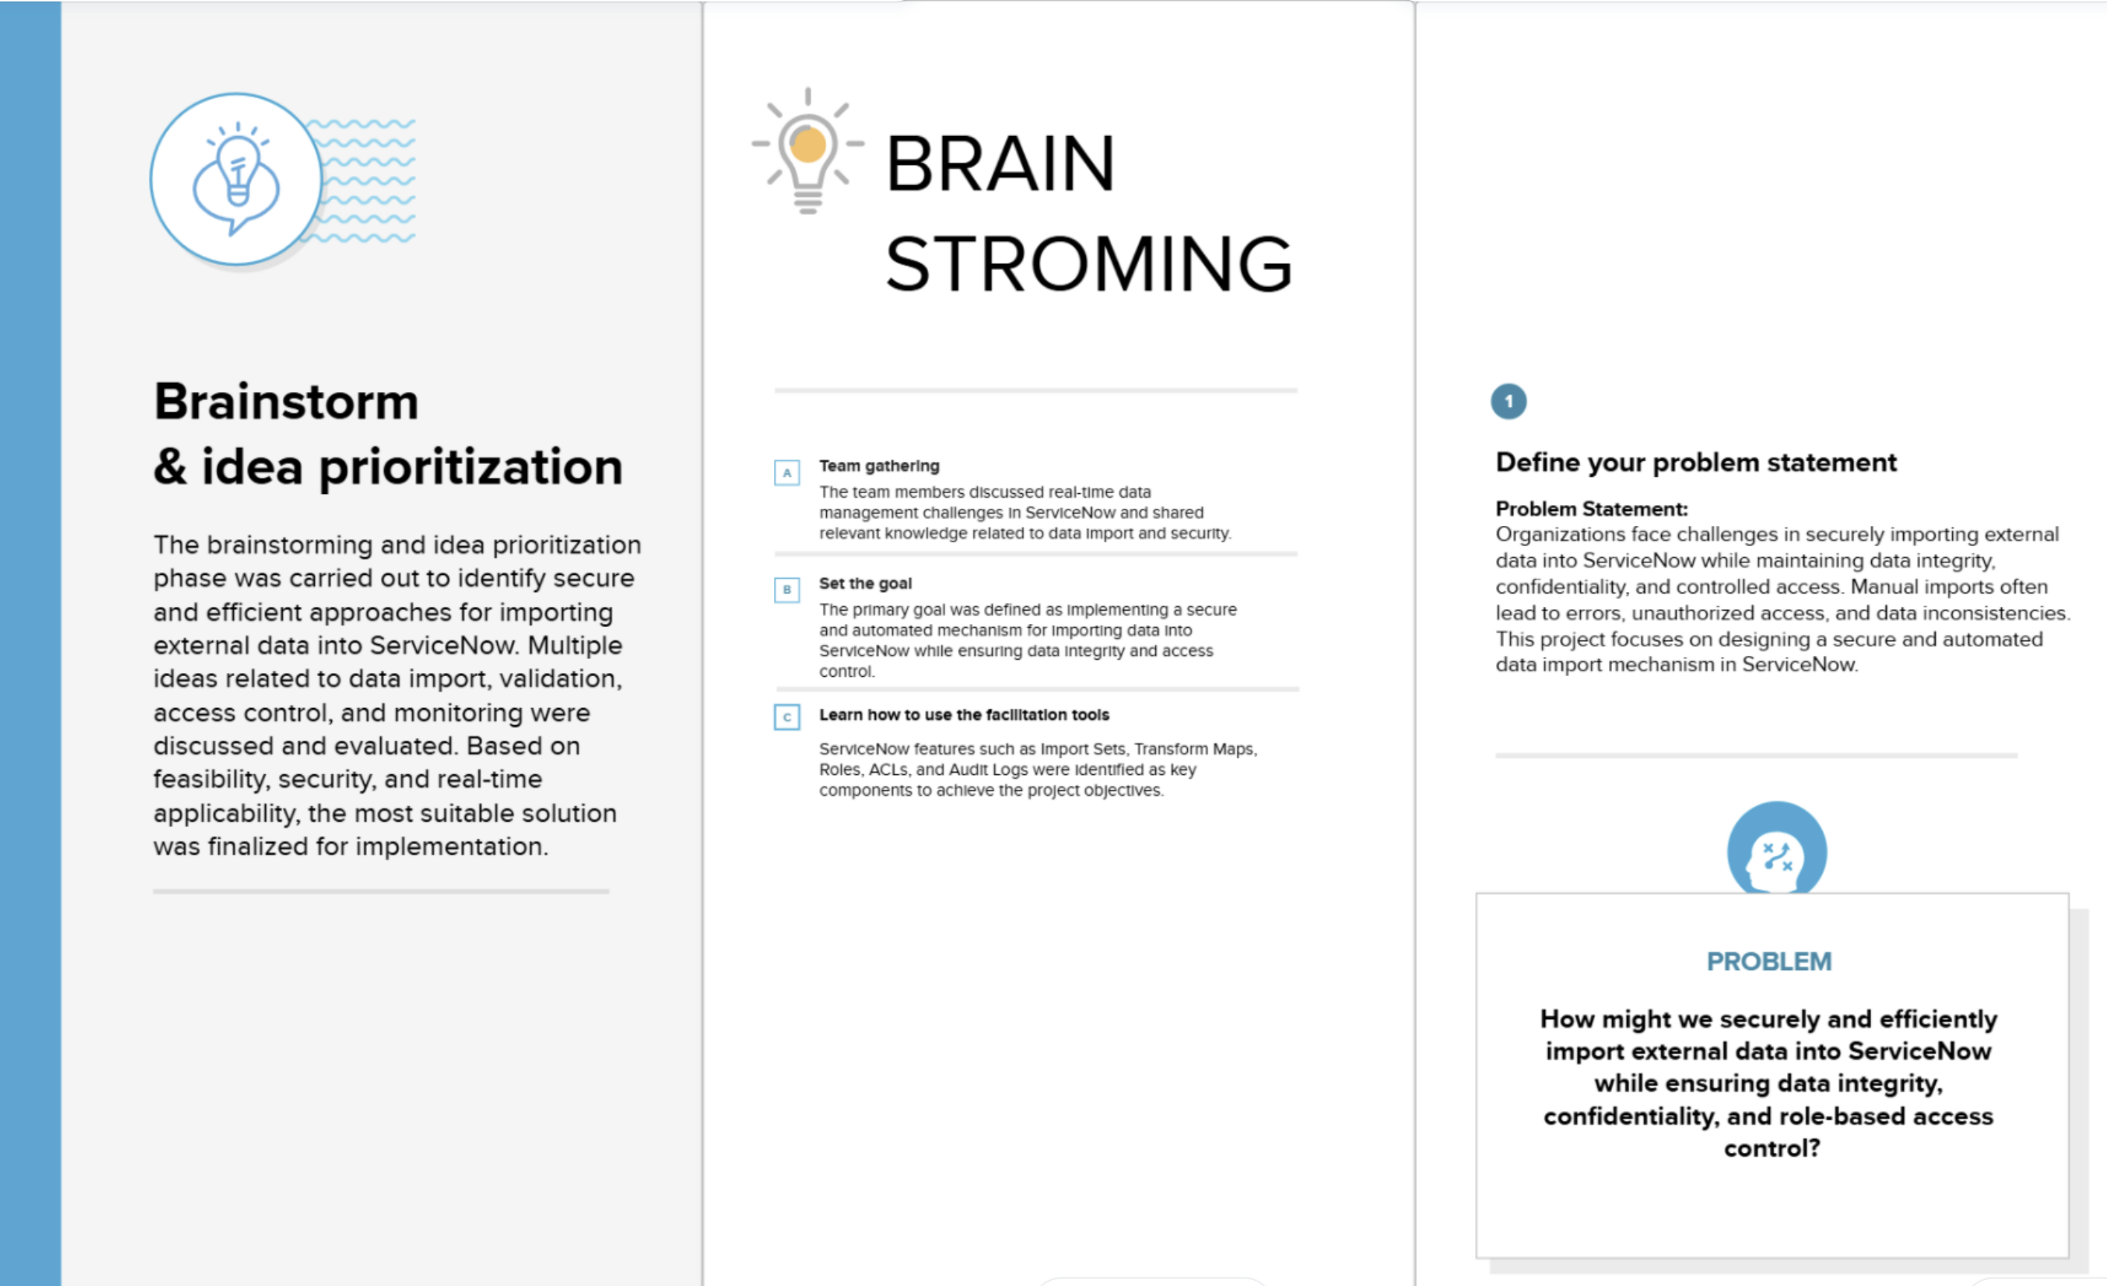

Step-2: Brainstorm, Idea Listing and Grouping
Various ideas related to secure data import were brainstormed, including import sets, transform maps, role-based access control, data validation, encryption, and audit logging. The ideas were grouped into categories such as data import mechanisms, security controls, automation, and monitoring.
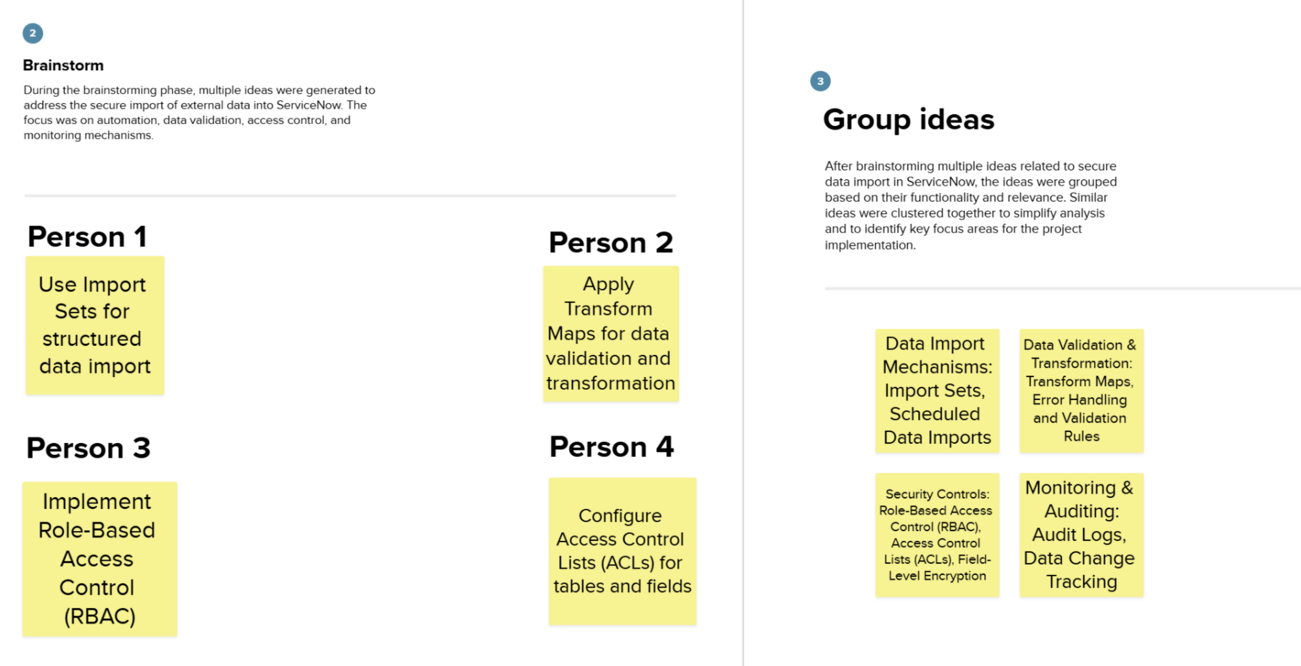

Step-3: Idea Prioritization
After grouping the ideas, they were prioritized based on importance, feasibility, and relevance to real-time ServiceNow implementation. Ideas that offered higher security, automation, and practical applicability were given higher priority.
Prioritization Criteria:
- Importance to data security and integrity
- Ease of implementation in ServiceNow
- Scalability and maintainability
Prioritized Ideas:
- High Priority: Import Sets, Transform Maps, Role-Based Access Control (RBAC), Access Control Lists (ACLs)
- Medium Priority: Field-Level Encryption, Audit Logs, Scheduled Imports
- Low Priority: Advanced customization and optional monitoring enhancements
This prioritization helped in selecting the most effective and feasible solution for secure data import and management in ServiceNow.

